# Colab and Github

Google’s adaptation of a Jupyter Notebook, Colab is an environment that makes it incredible easy to work in Python. Colab automatically handles installing nearly every possible library and runs your code on Google’s cloud servers, which come with GPUs, both of which can save you from a real headache. I recently learned how Colab files can be stored in github.

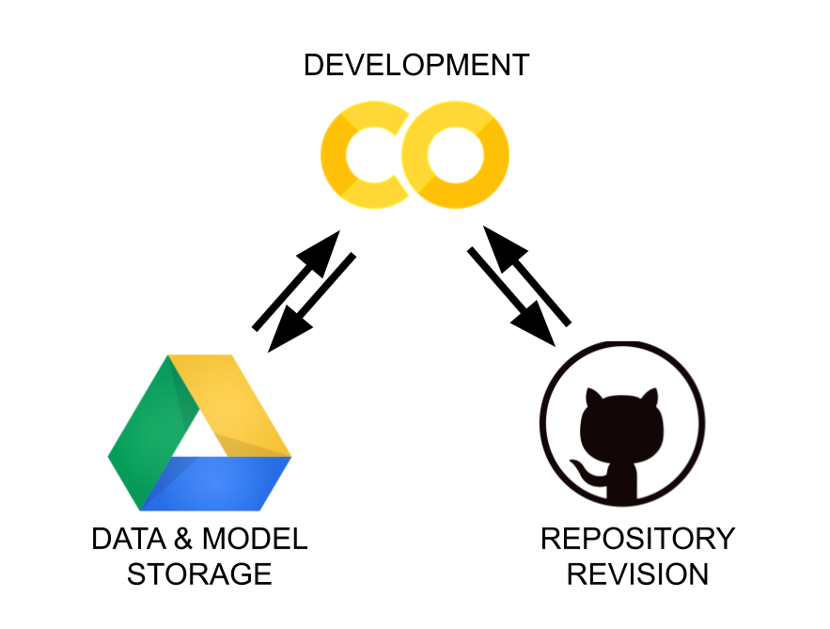

I use github to organize my code, store data, and manage my projects. Since most of my code is now written in Colab, it is super helpful to have these 2 systems merged.

Google drive and github are both file and data storage platforms, and Colab is where I actually do my work. When you create a new Colab notebook, it is automatically saved in you Google Drive.

To save an additional copy in github, in the drop down menu under File, click Save a Copy in Github towards the bottom of the menu. You will need to sign into your github account. The following pop up will appear:

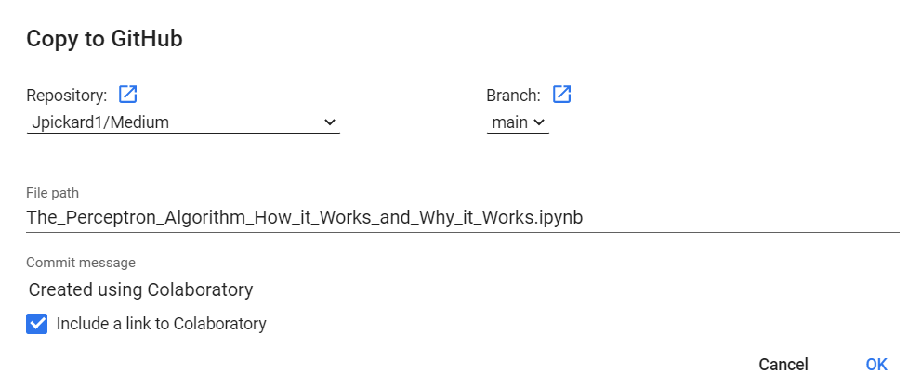

In this pop up, you can select which repository you want to save the Colab file in. The line for file path gives the name that file will be saved as in the repository and can be used to save in a specific subdirectory of the repository.

An important box to select is Include a link to Colaboratory. This makes sure that the file saved in your repository will be linked to the file saved in Google Drive. This link is circled in red below.

Once you click ok, Colab will create and commit the file to your repository. Below you can see a file I saved from Colab to my github and what it should look like. The notebook below is from an article about the Perceptron Algorithm for machine learning that you should check out!

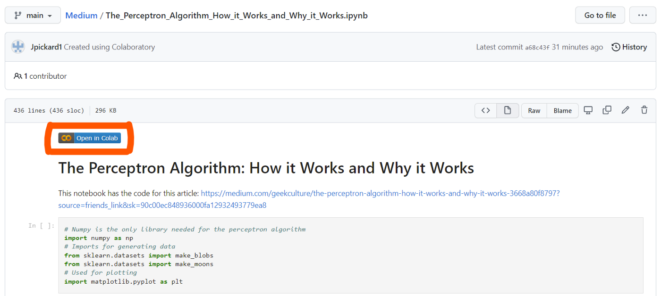

## Updating the File

Once you have the Colab file saved in github, the file is stored in 2 places, and you need to be careful of how you update it. Working on the file in Colab, the changes will automatically be saved to Google drive, but you will need to repeat the above process to keep the file up to date in your repository.